Serverless with AWS Lambda
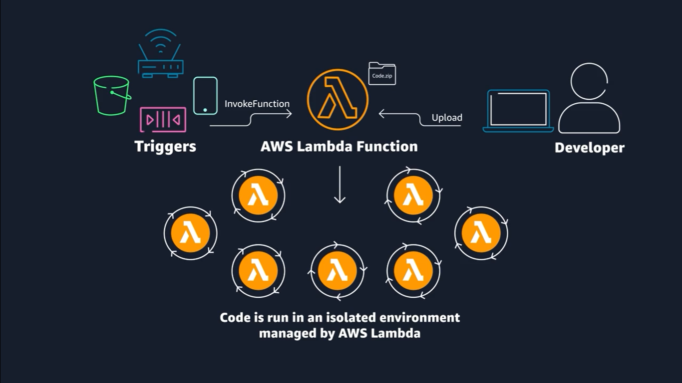

- Purpose:
- Run workloads and applications without managing EC2 instances or containers.
- Description:
- AWS Lambda is a serverless compute service that lets you run code without provisioning or managing servers.
- Use Cases:
- Supports various applications such as data processing, real-time stream processing, machine learning, IoT and mobile backends, WebSocket, and web applications.
- Operation:
- Runs code on highly available infrastructure with no user administration.
- You simply upload your source code in a supported language, and Lambda handles deployment, scaling, and availability.

- Key Benefits:
- No servers to manage.
- Automatic scaling with subsecond billing.
- Consistent performance and high availability built in.

Working:
- Core Concept:
- The Lambda function is the basic building block of AWS Lambda.
- Configuration Options:
Can be configured using:
- AWS Management Console
- Lambda API
- AWS CloudFormation
- AWS Serverless Application Model (AWS SAM)
- Invocation Methods:
- Direct invocation: Call the function using the Lambda API.
- Event-driven invocation: Automatically triggered by AWS services or resources in response to specific events.

Resources
For more information, see the following resources:
(opens in a new tab)(opens in a new tab)
- AWS website: Building Applications with Serverless Architectures(opens in a new tab)
- AWS blog: Best Practices for Organizing Larger Serverless Applications(opens in a new tab)
- AWS developer guide: Configuring AWS Lambda Functions(opens in a new tab)
- AWS blog: 10 Things Serverless Architects Should Know(opens in a new tab)
- AWS workshop: AWS Alien Attack: A Serverless Adventure(opens in a new tab)
- AWS blog: Resize Images on the Fly with Amazon S3, AWS Lambda, and Amazon API Gateway(opens in a new tab)
- AWS blog: New for AWS Lambda – 1ms Billing Granularity Adds Cost Savings

